**BANK LOAN REPORT QUERY DOCUMENT**

**1. BANK LOAN REPORT | SUMMARY**

**KPI’s:**

**Total Loan Applications**

SELECT COUNT(id) AS Total_Applications FROM loan_data



**MTD Loan Applications**

SELECT COUNT(id) AS total_applications FROM loan_data

WHERE MONTH(issue_date) = 12



**PMTD Loan Applications**  
SELECT COUNT(id) AS total_applications FROM loan_data

WHERE MONTH(issue_date) = 11



**Total Funded Amount**

SELECT SUM(loan_amount) as total_funded

from loan_data;

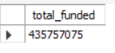

**MTD Total Funded Amount**

SELECT SUM(loan_amount) AS total_funded FROM loan_data

WHERE MONTH(issue_date) = 12



**PMTD Total Funded Amount**

SELECT SUM(loan_amount) AS total_funded FROM loan_data

WHERE MONTH(issue_date) = 11



**Total Amount Received**

SELECT SUM(total_payment) as total_received

from loan_data;



**MTD Total Amount Received**

SELECT SUM(total_payment) AS total_received FROM loan_data

WHERE MONTH(issue_date) = 12



**PMTD Total Amount Received**

SELECT SUM(total_payment) AS total_received FROM loan_data

WHERE MONTH(issue_date) = 11



**Average Interest Rate**

SELECT ROUND(AVG(int_rate)*100,2) AS avg_int_rate FROM loan_data;



**MTD Average Interest Rate**

SELECT ROUND(avg(int_rate)*100,2) as 'avg_int rate' from loan_data

where MONTH(issue_date) = 12;



**PMTD Average Interest Rate**

SELECT ROUND(AVG(int_rate)*100,2) as 'avg_int rate' from loan_data

where MONTH(issue_date) = 11;



**Avg DTI (DEBT TO INCOME RATIO)**

SELECT ROUND(AVG(int_rate),2) AS avg_int_rate FROM loan_data;

**MTD Average DTI**

SELECT ROUND(avg(dti)*100,2) as 'avg_dti' from loan_data

where MONTH(issue_date) = 12;



**PMTD Average DTI**

SELECT ROUND(avg(dti)*100,2) as 'avg_dti' from loan_data

where MONTH(issue_date) = 11;



**Good Loan Issued:**

**Good Loan Percentage**

SELECT

    (COUNT(CASE WHEN loan_status = 'Fully Paid' OR loan_status = 'Current' THEN id END) * 100.0) /

COUNT(id) AS Good_Loan_Percentage

FROM loan_data;

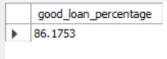

**Good Loan Applications**

SELECT COUNT(id) as ‘good_loan_applicaions from loan_data

where loan_status = 'Fully Paid' OR loan_status = 'Current';

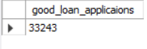

**Good Loan Funded Amount**

SELECT SUM(loan_amount) as ‘good_loan_funded_amount from loan_data

where loan_status = 'Fully Paid' OR loan_status = 'Current';



**Good Loan Amount Received**

**Good Loan Amount Received**

SELECT SUM(total_payment) as ‘good_loan_amount_received from loan_data

where loan_status = 'Fully Paid' OR loan_status = 'Current';

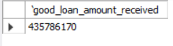

**Good Loan Issued:**

**Bad Loan Percentage**

SELECT

    (COUNT(CASE WHEN loan_status = ‘Charged Off' THEN id END) * 100.0) /

COUNT(id) AS Bad_Loan_Percentage

FROM loan_data;



**Bad Loan Applications**

SELECT COUNT(id) as ‘bad_loan_applicaions from loan_data

where loan_status = 'Charged Off';



**Bad Loan Funded Amount**

SELECT SUM(loan_amount) as bad_loan_funded_amount from loan_data

where loan_status = 'Charged Off';

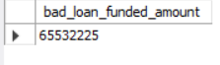

**Good Loan Amount Received**

SELECT SUM(total_payment) as bad_loan_amount_received from loan_data

where loan_status = 'Charged Off';

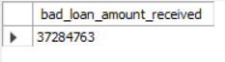

**LOAN STATUS**

SELECT

loan_status,

count(id) AS total_loan_applications,

sum(loan_amount) as total_funded_amount,

sum(total_payment) as total_amount_received,

round(avg(int_rate) *100,2) as average_interest_rate,

round(avg(dti) *100,2) as average_dti

from loan_data

group by loan_status;

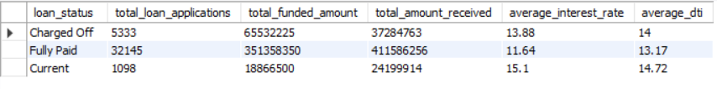

SELECT

loan_status,

SUM(total_payment) AS MTD_Total_Amount_Received,

SUM(loan_amount) AS MTD_Total_Funded_Amount

FROM bank_loan_data

WHERE MONTH(issue_date) = 12

GROUP BY loan_status;

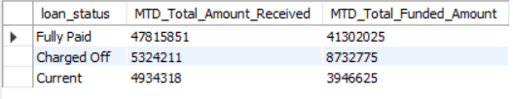

**2. BANK LOAN REPORT | OVERVIEW**

**MONTH**

SELECT

MONTH(issue_date) AS Month_Number,

MONTHNAME(issue_date) AS Month_name,

COUNT(id) AS Total_Loan_Applications,

SUM(loan_amount) AS Total_Funded_Amount,

SUM(total_payment) AS Total_Amount_Received

FROM loan_data

GROUP BY Month_Number, Month_name

ORDER BY Month_name;

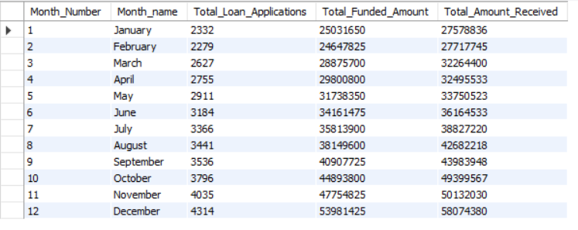

**TOP 10 STATES LOAN APPLICATION WISE**

SELECT

COUNT(id) AS total_loan_applications,

SUM(loan_amount) AS total_funded_amount,

SUM(total_payment) AS total_amount_received

FROM loan_data

GROUP BY STATE

ORDER BY total_loan_applications desc

LIMIT 10;

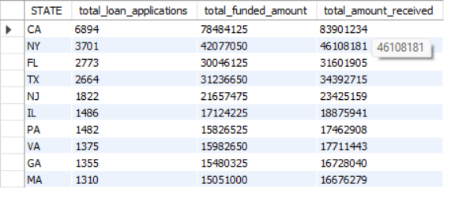

**TERM**

SELECT

term,

COUNT(id) AS total_loan_applications,

SUM(loan_amount) AS total_funded_amount,

SUM(total_payment) AS total_amount_received

FROM loan_data

GROUP BY term

ORDER BY term;

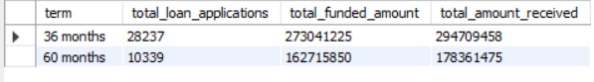

**EMPLOYMENT LENGTH**

SELECT

emp_length

COUNT(id) AS total_loan_applications,

SUM(loan_amount) AS total_funded_amount,

SUM(total_payment) AS total_amount_received

FROM loan_data

GROUP BY emp_length

ORDER BY emp_length;

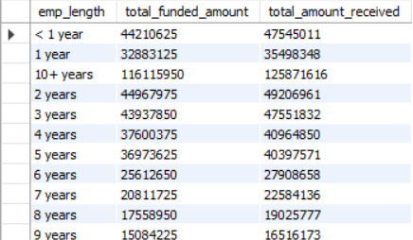

**PURPOSE**

SELECT purpose,

COUNT(id) AS total_loan_applications,

SUM(loan_amount) AS total_funded_amount,

SUM(total_payment) AS total_amount_received

FROM loan_data

GROUP BY purpose

ORDER BY COUNT(id) desc;

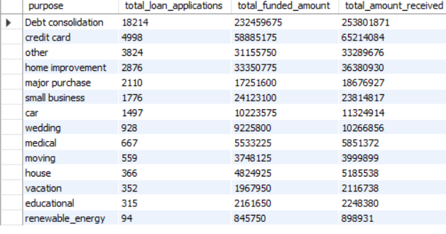

**HOME OWNERSHIP**

SELECT home_ownership,

COUNT(id) AS total_loan_applications,

SUM(loan_amount) AS total_funded_amount,

SUM(total_payment) AS total_amount_received

FROM loan_data

GROUP BY home_ownership

ORDER BY COUNT(id) desc;

